At death of the first spouse, surviving spouses receives the higher of:

* Their own monthly benefit, or
* The monthly benefit of the deceased.

That’s the clean and straightforward answer, but it’s not quite that simple.  Although Social Security survivor benefits really are pretty simple, every family is different.  Unique situations and variables can introduce some complexity.

 Calculating the Benefit Amount

Figuring out how much you’ll receive in Social Security survivor benefits requires a little math.

The simple explanation is that at the death of the first spouse, surviving spouses receives the higher of:

* Their own benefit, or
* The benefit of the deceased.

But this simple explanation doesn’t consider the two main factors that will determine this amount.

Those two factors are:

(a) what age the deceased filed for benefits and  
(b) when the surviving spouse decides to file.

If The Deceased Never Filed For Benefits

If the deceased spouse never filed for benefits, but died on or *before* their full retirement age, the calculation is relatively easy. The survivor receives the deceased’s full retirement age benefit, adjusted for the survivors’s filing age. (See chart below in Step #2 for age-based reductions.)

If the deceased spouse never filed for benefits, and died *after* their full retirement age, the calculation is still easy. The survivor receives the deceased’s benefit in the same amount it would have been on the date of his death (including delayed retirement credits,) reduced for the filing age of the survivor.  (See chart below in Step #2 for age-based reductions.)

If The Deceased Filed For/Was Receiving Benefits

But what if the deceased spouse filed for benefits before he passed away? If this is the case, it is just a little more complicated.  You’ll have to use both steps listed below to determine the benefit amount.

Step #1: Determine MAXIMUM Survivor Benefit

The maximum survivor’s benefit is the *most* that a surviving spouse will receive at their full retirement age. This maximum amount will then be reduced for the survivor’s filing age.

If the deceased spouse filed *before* full retirement age, the surviving spouse is entitled to a*maximum* of:

a) the actual benefit the deceased was receiving or  
b) 82.5% of the deceased’s full retirement age benefit, whichever is higher. (More on this weird 82.5% rule in a moment.)

If the deceased spouse filed for benefits *after* full retirement age, the surviving spouse is entitled to a maximum of the actual benefit of the deceased including any credits for delayed filing.

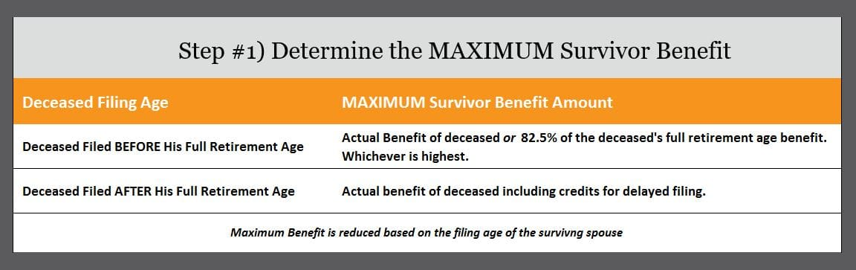

Step #2: Age-Based Reduction to Maximum Benefit

Once you calculate the maximum Social Security survivor’s benefit, you then need to find out how much of that benefit you are entitled to receive. Unless you are disabled, you can file for widow’s benefits as early as age 60. If you do, there’ll be a 28.5% reduction to the maximum benefit amount. As you get closer to your full retirement age, the reduction starts to lessen until it goes away completely at your survivor’s full retirement age. The chart below illustrates how a Social Security survivor benefit will be reduced based on the survivor’s age.

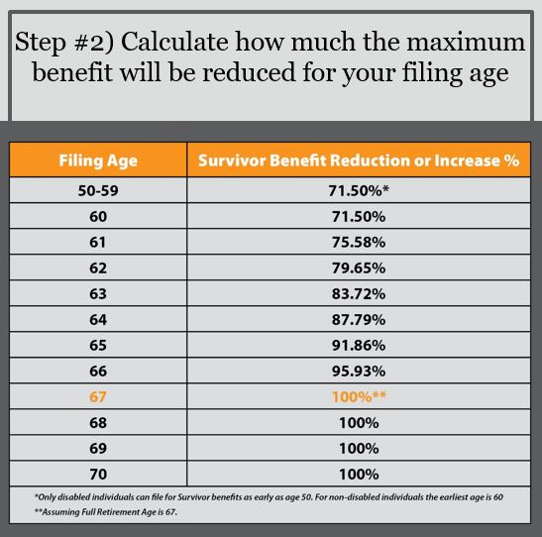

When It DOESN’T Pay to Delay Filing (the weird 82.5% rule)

If your deceased spouse filed for benefits before their full retirement age, there is an additional rule you need to know. The Social Security Administration has a “widow’s limit” that comes into effect if your deceased spouse filed for benefits early. This rule simple states that if your deceased spouse filed early, you’ll be forever limited to either the amount they were actually drawing, or 82.5% of their full retirement age benefit.

So, if this describes your situation, you need a filing plan! Heck…you need a filing plan anyway, but especially if your deceased spouse filed early.

Here’s why. There may not be a reason to delay filing for survivor benefits beyond your age 62 and 4 months!

For example, let’s assume Jim’s full retirement age benefit was $2,000. However, he filed at 62 and began receiving and age-based reduced benefit of $1,500. Two years later he died. Because of his early filing, the MOST his surviving spouse will receive is the greater of his actual benefit ($1,500) or 82.5% of his full retirement age benefit ($2,000 x 82.5% = $1,650)

If you’ll check the chart in step #2 above, you’ll see that she’d hit the 82.5% ($1,650) of his benefit right in between age 62 and 63 (62 and 4 months to be precise). This means that there would be *no reason* to wait beyond her age 62 and 4 months to file for survivor benefits.

Advanced Filing Strategies for Survivors

Law changes in 2016 did away with many of the Social Security filing strategies. The one that remains belongs to survivors and it can be *powerful*. It works like this.

If you have a benefit based on your own work history, it could make sense to file for a reduced survivor’s benefit as early as 60. While you are drawing your survivor benefit, your own benefit is growing every month you delay filing for it. Generally, these adjustments could grown your benefit by 77% from age 62 to age 70. At age 70, you simply switch back to your own benefit (which is now higher).

Here’s an example:

Paula has her own benefit of $1,500 per month that she could take at 67, her full retirement age. Her husband passed away and she is eligible for a survivor benefit of $1,200 per month. If she restricts her application to a survivor benefit only, she can collect benefits while letting her own benefit grown.

Age 62-69 : $1,200 per month – Survivor Benefit  
Age 70+     : $1,860 per month – After switching to her own benefit

The Social Security Administration discusses this strategy at [this link](https://www.ssa.gov/planners/survivors/survivorchartred.html).

Earnings Limit

If you file for any Social Security retirement benefit (your own, spousal or survivor’s) before your full retirement age, there is a limit to how much you can earn. The fact that this also applies to survivor benefits will often catch individuals by surprise.

If you are under full retirement age you are limited to $16,920 in wages or net earnings from self employment. If you exceed that limit, your benefit will be reduced by $1 for every $2 you go over. The one exception is the calendar year you turn full retirement age. For that period, your limit is a much higher $44,880. The amount they’ll reduce your benefit by is more generous as well.

Once you are full retirement age, there is no limit to the amount you can earn while drawing Social Security.

